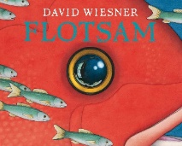  English  Our core text will be the wordless picture book, Flotsam. Through this text engage in role play and debates to supplement our genres such as persuasive writing.  In addition, we will continue our Jolly Grammar twice a week with standalone spelling and grammar lessons to aid our writing. | Maths  We will continue with number, using 10s, 100s and 1000s to multiply/divide large numbers. We will move onto geometry in particular angles and shapes before exploring fractions. | Spanish  We will follow a story and join in the repeated parts, say what foods from a set we like/dislike, describe the colour of an object and finally, ask politely for something. | Physical Education  Swimming - We will attend a weekly swimming lesson at our nearby pool.  Dance - We will combine a number of movement/patterns. We will begin to understand the importance of warming up and identify strengths/areas we could improve. | Design Technology  We will learn to join textiles of different types in different ways and choose textiles both for their appearance /qualities. Following on, we will explore  accurately making cuts and holes to join materials. Finally we will carry out an evaluation and discuss what we would change to improve our designs.
Geography –  We will find out what coasts are and how they are formed, the physical features of coasts and the processes of erosion that affect them. In addition, we will explore different strategies of coastal management and identify different types of beaches. We will use maps and secondary sources to research and describe coastal areas and learn how changes in land use will affect people and the environment in different ways. | 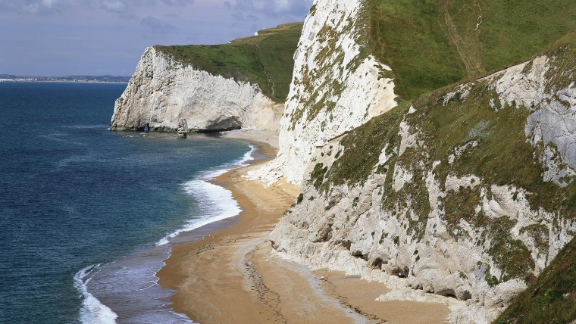  Year 3  Spring 1 |  |  | 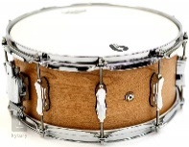  Music  Through our weekly drumming lessons, we will maintain a steady beat on an instrument in a group or individually. In addition, we will copy a short melodic phrase by ear on a pitched instrument and using symbols including graphic and / or simple traditional notation. At the end of our unit, we will perform with an awareness of others and combine musical sounds with narrative and movement.
Science – Forces (and Magnetism)  We will compare how things move on different surfaces and know how a simple pulley works and can make lifting an object simpler. In addition, we will explore how forces need contact between two objects, but magnetic forces can act at a distance and observe how magnets attract and repel each other and attract some materials and not others. We will compare and group together a variety of everyday materials on the basis of whether they are attracted to a magnet, and identify some magnetic materials. Finally, we will describe magnets as having two poles and predict whether two magnets with attract or repel each other, depending on which poles are facing. |  | Computing – internet skills  We will identify the ways, and investigate how, we communicate online. We will explain why it is important to be responsible online. | RSE  We will explore challenges and achieving success through our dreams and ambitions.  In addition, we will discuss motivation and enthusiasm, managing feelings and recognising/overcoming obstacles. | 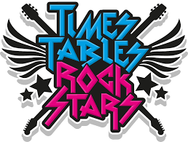  Home/School  We will continue to enjoy our weekly home reader/reading for pleasure book. We will continue to practise our tricky word flashcards and work on our times table rockstars.

