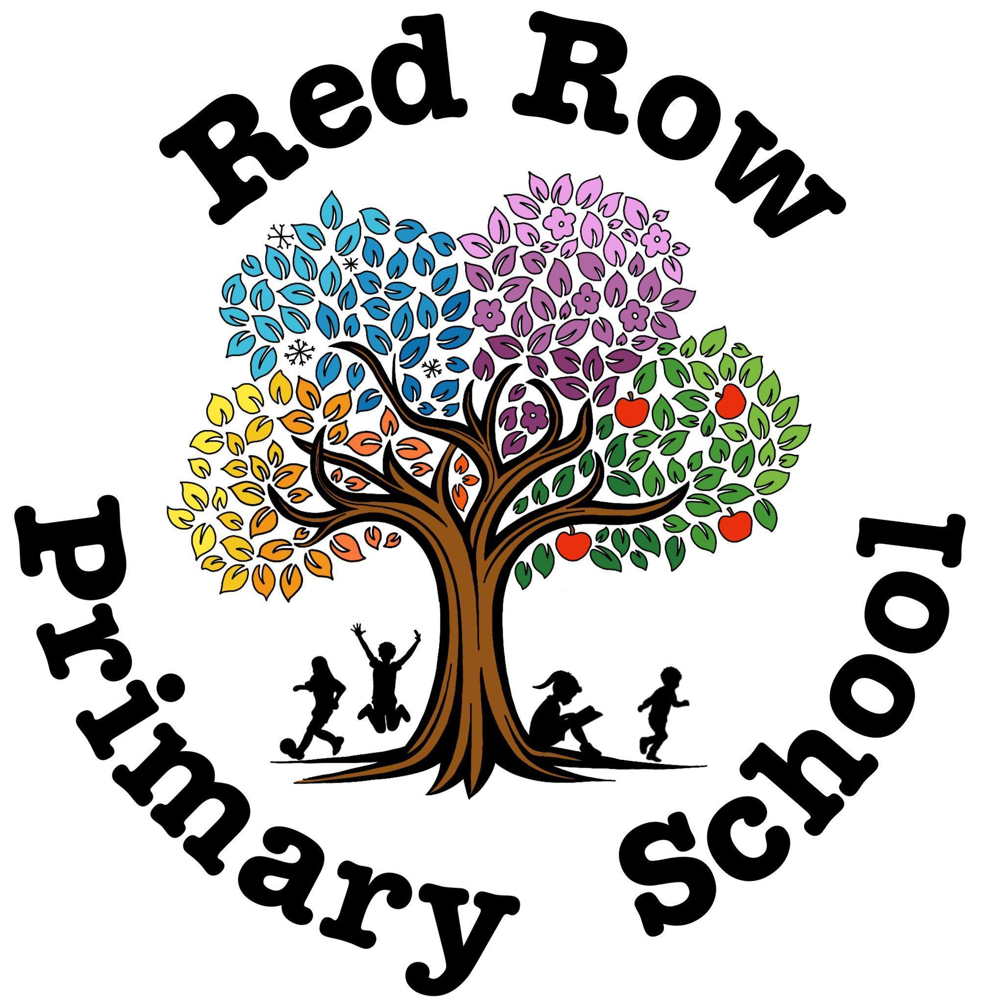
SCHOOL NEWSLETTER 08/05/2026

🌟 Star Awards 🌟
Our Star Awards celebrate children who have shown excellent effort, kindness, teamwork, resilience and a fantastic attitude to learning ⭐ We are so proud of all the children for trying their best, being good friends and shining brightly every day 🌈✨ Keep up the amazing work superstars! 🌟
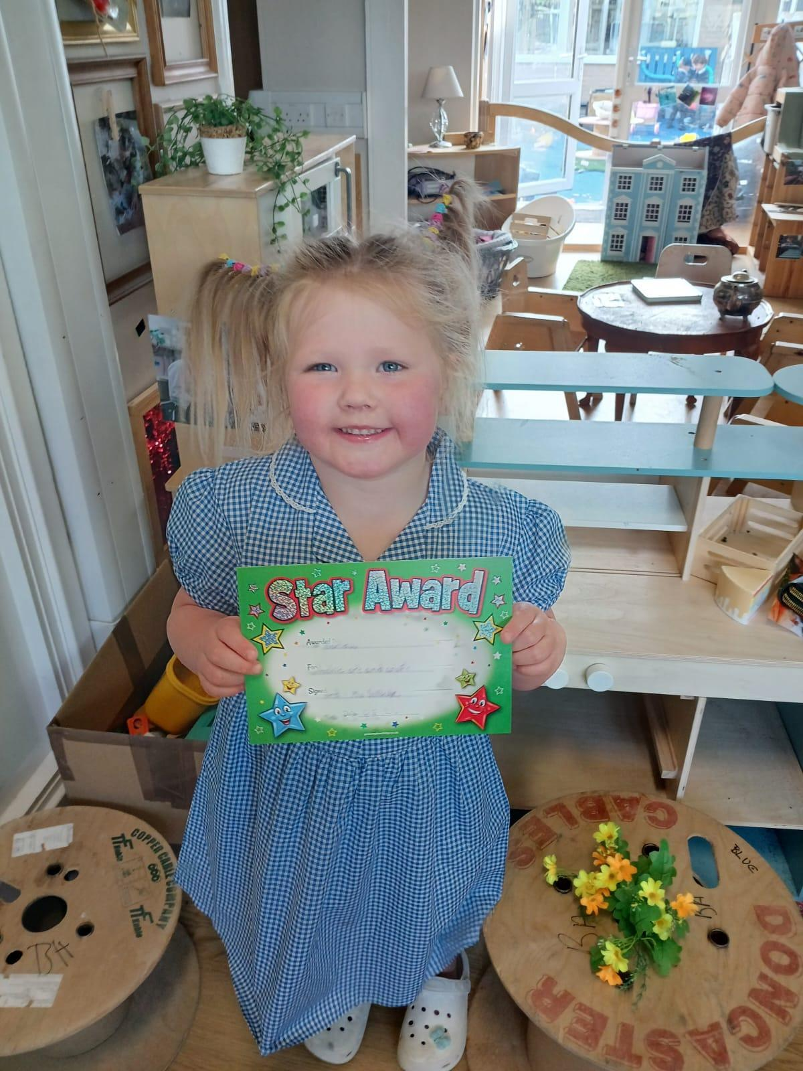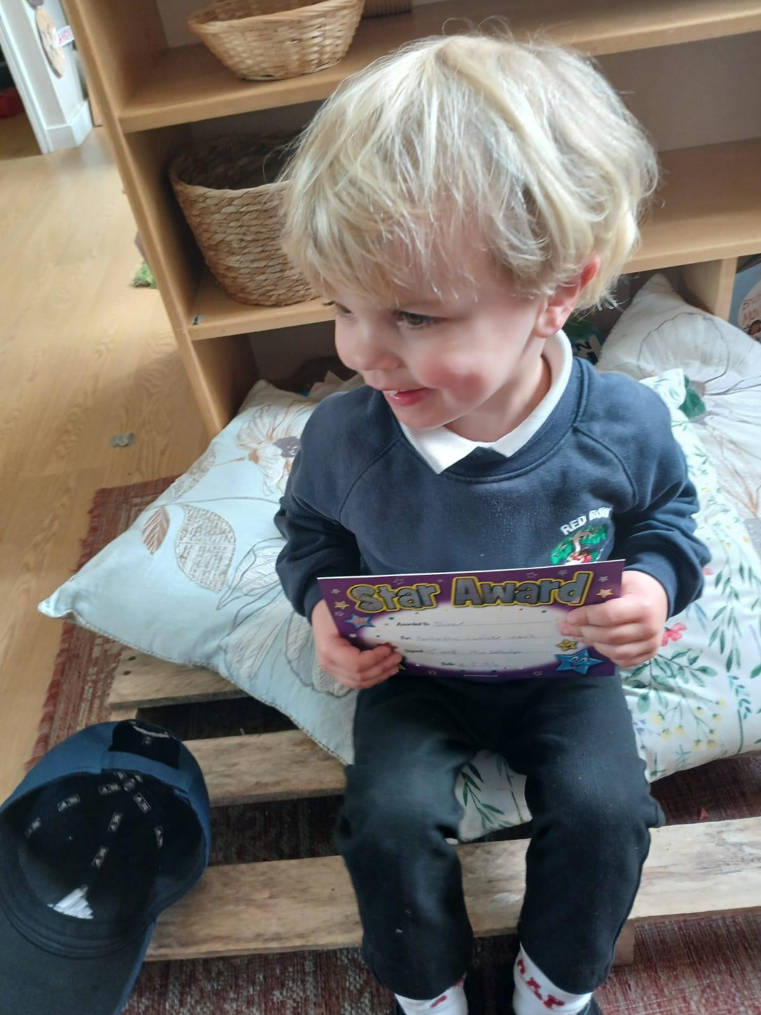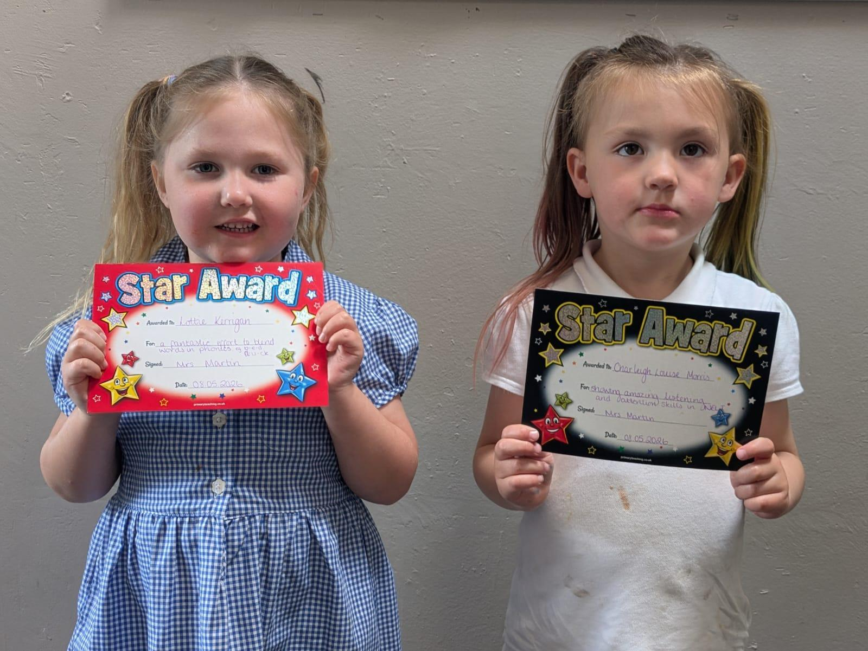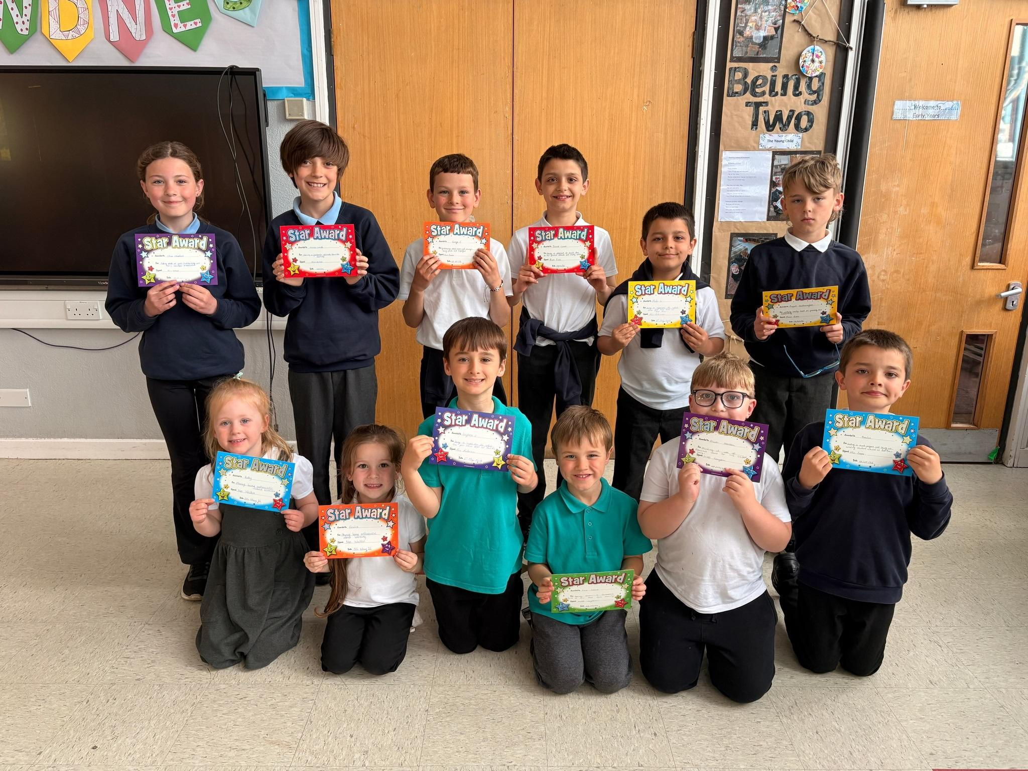

 Special Announcements

💙⭐A huge special goodbye to Matei, Ionatan & DavId Lucut who are off to school in Romania. We will miss you all so much and wish you lots of happiness and success in your new school adventure! 💙⭐

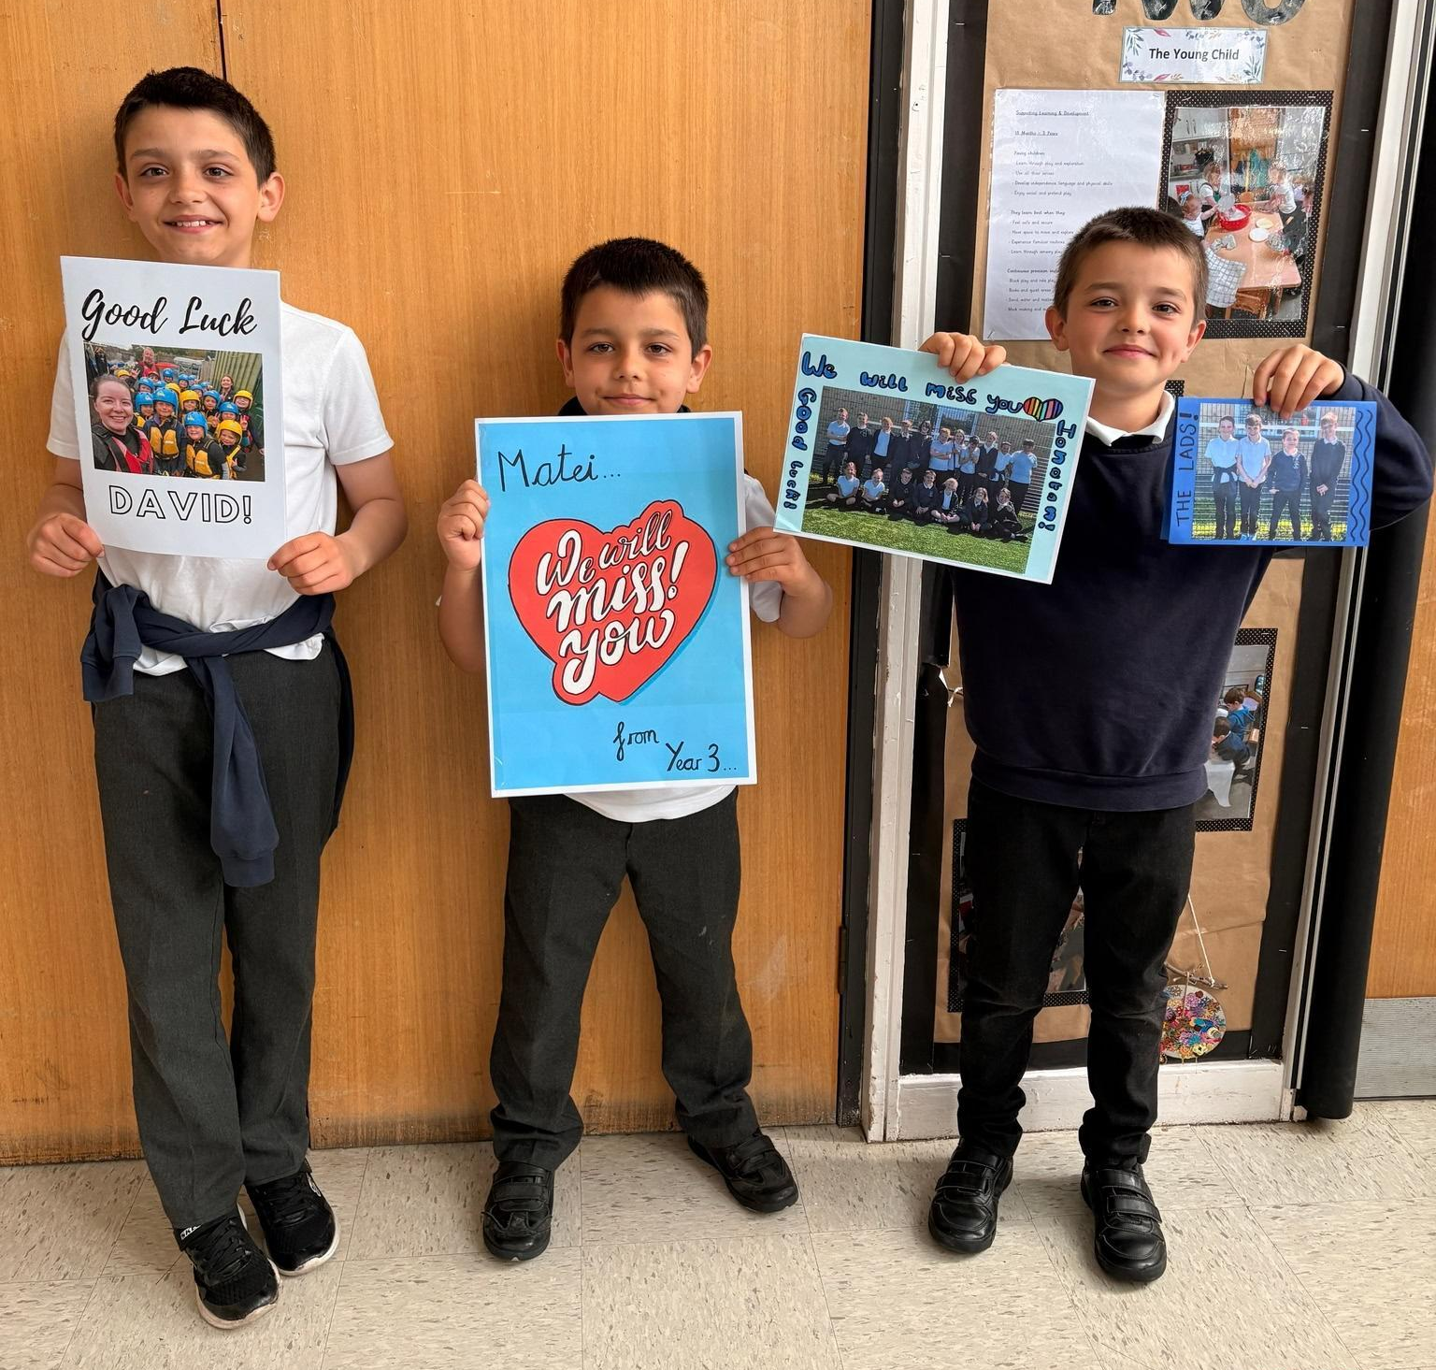

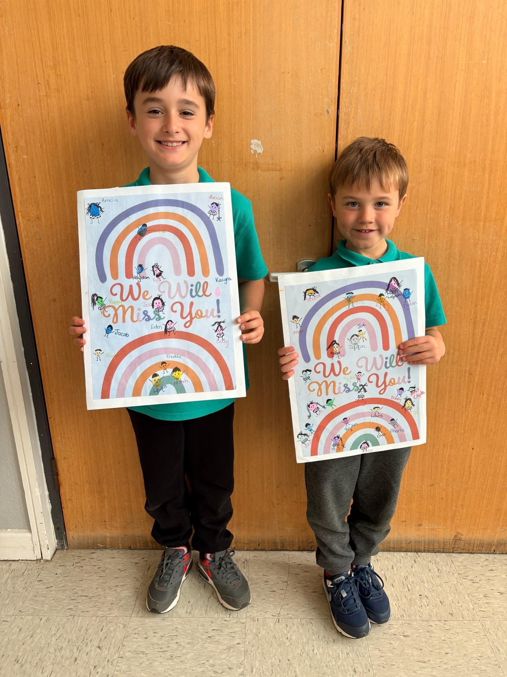

A special goodbye as well to Leighton & Cole Crowe who have now gone to Grange View Primary. Good luck in your new school — we know you will all do amazing things! 🌈🍀

 Dates for your Diary



📝 Y6 SATs — Monday to Thursday - Good luck Year 6! Believe in yourselves and do your best ⭐💪
👨‍👩‍👧 Robinwood Parents Meeting — Monday at 3:15pm
🏏 Y4/Y5 Cricket — Wednesday - Have fun! 🎉
👕 Non-School Uniform Day — Friday - Please bring a prize donation 🎁✨

🗓️ Attendance🗓️
Every school day counts. Be here, be on time, and help your child reach their full potential.

Whole School Attendance: 95.70%
Reception - 100% - Well done Reception!! 🙋‍♂️🙋🏻‍♀️
Year 1 / 2 - 92.93%
Year 3 - 98.33%
Year 4 - 96.05%
Year 5 - 100% - Well done Year 5!! 🙋‍♂️🙋🏻‍♀️
Year 6 - 99.04%

 Reminders

🎒Please complete the survey to order your school uniform for September. The deadline is Monday 8/6/26. https://www.smartsurvey.co.uk/t/UniformOrder2026/ 🎒

🍽️School Dinners🍽️
Please book & pay for your school dinners via SchoolMoney app.

🥣Breakfast Club🥣
Doors open 8:15am and close at 8:30am. This is FREE and no booking required. If you would like to join our volunteers for Breakfast Club, please message me on Class Dojo. The Breakfast Club is very busy and we could do with extra pairs of hands.

🎲After School Clubs🎲
All clubs need to be booked in advance and paid for at the time of booking on School Money please.

🧒Little Acorns/Nursery Places – September 2026🧒
If you, or someone you know of need a Little Acorns (2 year olds)/Nursery place for a child in September 2026 please come to the office for a form.

🧑‍🏫Contacting your child’s teacher🧑‍🏫
If you need to speak with your child’s teacher please either catch them on the yard or pop them a message on Dojo and they will respond as soon as they are able to (when not teaching). Thank you.

𖠋♡𖠋 OneCall 𖠋♡𖠋
OneCall is one number you can call for all children’s services, safeguarding or adult social care concerns in
Northumberland, helping to keep the most vulnerable people safe and well 24-7. If you are concerned about a child or young person please call 01670 536400 or email childrentriage@northumberland.gov.uk

🤒Is my child well enough for school?🤒
We aim for every child to achieve 100% attendance. Where attendance falls below 97%, our attendance procedures will begin, which may include support from the Education Welfare Officer. Parents and carers may find the following NHS guidance helpful when deciding whether their child is well enough to attend school:
NHS: Is my child too ill for school?
If your child is feeling slightly unwell but is otherwise able to participate in normal school activities, appropriate medication (such as Calpol, where suitable and used according to the manufacturer's instructions) may help them attend school comfortably. However, parents should use their own judgement and follow NHS guidance when deciding whether their child is fit to attend.
If your child becomes unwell during the school day, we will contact you immediately.
💸Easy Fundraising – for the Friends of Red Row Primary School💸
We have signed up to Easy Fundraising, which donates money to the Friends when you shop online. You can sign up using this link: https://www.easyfundraising.org.uk/causes/redrow1st

👔Uniform👔
A reminder that shoes/trainers should be all black for school through the week, and any trainers on a PE
day. No crocs allowed. Also, please make sure that every single item of your child’s uniform has their name inside it. Staff are not responsible for lost uniforms, especially if it does not have your child's name on it.

🆓Pupil Premium/Free School Meals🆓
It is quick and easy to check if your child is eligible for free school meals. This is different from Universal Free School Meals, which are available to all children in Reception, Year 1 and Year 2. If your child is eligible, you may receive support such as subsidised educational visits and free milk. The school will also receive additional funding to help provide resources and support for your child.To check if you qualify, call 0345 600 6400. They can check your eligibility using your National Insurance number. Please consider applying – it could benefit both your child and the school. Thank you.
☎️Emergency Contacts/Up to Date Information🖂
For safeguarding reasons, we need two emergency contact numbers for every child in school. We also need up-to-date email addresses and home addresses for all parents and carers. If any of your contact details have changed recently, please let the school office know as soon as possible.

Thank you for your continued support. We hope you all have a wonderful week!

