English  We will continue to revise our grammar through our Jolly Grammar scheme of work Our key texts below lend themselves to a unit of poetry (the spider and the flu) and the non-fiction unit will enable children to retrieve information as well as make inferences about real-life characters. It lends itself to focussing on persuasive writing, writing to explain as well as non-chronological report writing. | Maths  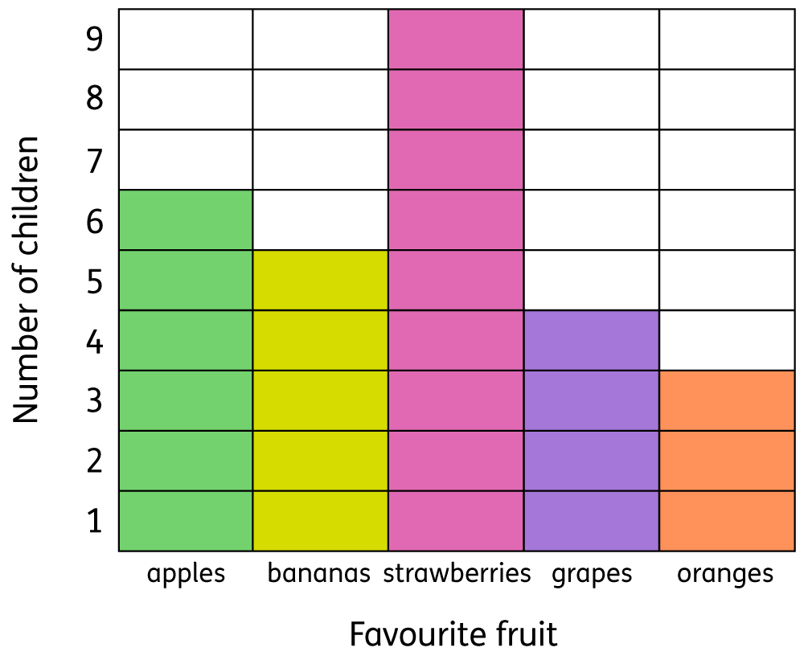  Children will continue developing their number skills, exploring calculation strategies within and beyond 100.  They will then move onto a unit of measurement exploring money, in particular, before developing their graph skills in statistics. | Physical Education - Dance  Children will perform with control and consistency using basic actions at different speeds and on different levels. They will be encouraged to challenge themselves to move imaginatively responding to music. Additionally, they will work as part of a group to create and perform short movement sequences to music. | Design Technology - Clay  Children will focus on using clay and make a clay pot. They will explore joining two finger pots together and adding lines and shape to their work.  In addition, a focus will be on evaluation, children will describe what went well with their work  And evaluate what they would do differently if they did it again and why. They will judge their work against the design criteria.
Art – Renata Rehorovska  Children will create individual and group collages, using different kinds of materials on their collages explaining why they have chosen them. In addition, children will use repeated patterns in my collage.  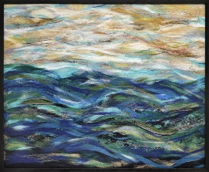  In sketchbooks, children will create different tones using light and dark and use a viewfinder to focus on a specific part of an artefact before drawing it. | Year 2  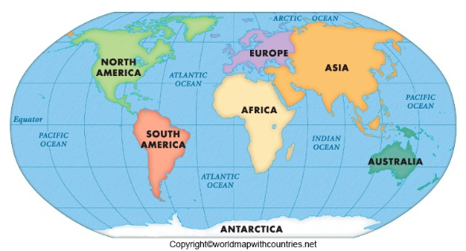  Spring 1 | Computing  Children will explore using technology purposefully to create, organise, store, manipulate and retrieve digital content. They will learn to use technology safely and respectfully, keeping personal information private; identify where to go for help and support when they have concerns about content or contact on the internet or other online technologies. | Music (exploring/composing)  Children will explore ways in which sounds are made and how sounds can be manipulated to convey different effects and moods.  In addition, children will compose a piece of music that has a beginning, middle, end and music that has long and short sounds, and/or changes in tempo, timbre and dynamics, in small groups.
Science – Plants  Children will observe and describe how seeds and bulbs grow into mature plants.  Additionally, they will find out and describe how plants need water, light and warmth to grow and stay healthy. | Geography – Continents and Seas.  Children will locate and identify oceans and continents, find out about British beaches and seas and use fieldwork skills to find out about a place. They will compare a British beach with one from another country. | PHSE  Children will explore achieving realistic goals through perseverance, learning strengths, learning with others and group co-operation. | Home/School  We will reinforce the taught sounds in class through our Jolly Phonic home readers and enjoy our weekly reading for pleasure book. In addition, we will practise our tricky word flashcards and work on our times table rockstars.

