Personal, Social and Emotional Development  There will be a focus on beginning to understand how others might be feeling and developing appropriate ways of being assertive.  We will look at developing confidence in a range of social situations and explore finding solutions to conflicts and rivalries. | Communication and Language  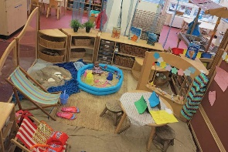  Children will focus on developing and maintaining concentration and listening with interest to the noises adults make when they read a story. They will engage in role play from own experiences and stories and talk about the story using the story language. | Physical Development  (Gymnastics/Dance)  Children are taught the importance of warming up before activity and stretching afterwards. They learn how their bodies change through exercise. Children are taught the vocabulary needed to develop their understanding of each skill and are expected to reflect on the skills they have learnt and identify ways they can develop.
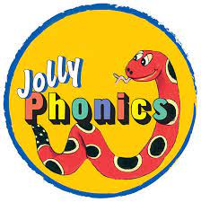  Literacy  Jolly Phonics – children will continue to be introduced to the Jolly Phonic single sounds through a selection of stories and actions.  Stories – we will listen to and talk about a variety of stories from the Pie Corbett Reading Spine. | 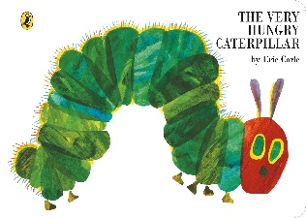  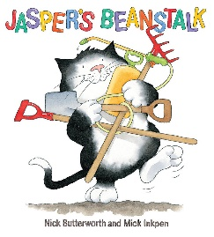  Nursery  Spring 1 | Expressive Arts and Design  We will explore shapes through art and design. We will learn to join different materials and explore different textiles before creating closed shapes with continuous lines. We will use these shapes to represent objects.  Additionally, through continuous provision, we will develop confidence in developing our own ideas and deciding which materials to use to express them.
Maths
We will explore rote counting activities, number recognition and counting games 0-5 & beyond. We will gain an understanding that not only objects, but anything can be counted, including steps, claps or jumps.
Understanding the World  Children will explore and discuss the different forces he/she can feel. They will discuss the differences between materials and changes he/she notices. | Home – School Learning  Reading for pleasure books will be changed every Friday – please share these with your child at home… they can use their imagination and tell the story through the pictures – it will be different EVERY time! | Continuous Provision  A variety of resources are provided both in the classroom and outside for children to creatively interact with. Continuous provision encourages the children to enhance previously taught concepts and make connections independently.

