Personal, Social and Emotional Development  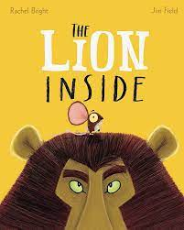  We will focus on settling in and separating from caregivers. There will be a focus on self-confidence, making relationships and ability to manage feelings. In addition, we will look at learning routines and following our school rules. | Communication and Language  We will baseline speaking, listening and understanding. In addition, we will introduce basic nursery rhymes, songs and daily tidy up song. | Physical Development  We will baseline gross motor skills, fine motor skills and health and self-care. After our baseline we will learn routines for self-care regarding food and drink, 30 hr toileting and hand washing and safe play e.g. water tray, scissors, height to climb outside etc. We will implement Funky Fingers challenges to support fine motor skills development Outdoor equipment is kept basic until safety rules are well established
Nursery
Autumn 2
All About Me!

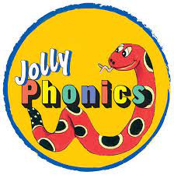  Literacy  Phonics – we will introduce the Jolly Phonic sounds through a selection of stories and actions.  Stories – we will listen to and talk about a variety of stories from the Pie Corbett Reading Spine. | 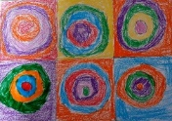  Expressive Arts & Design  We will have an art skills focus through drawing (pencil, charcoal, chalk, pastels) looking at Kandinsky’s work. We will also explore using a variety of mark making tools and explore different textures. | Maths  We will baseline number skills and shape, space and measure skills. Then we will focus on basic counting skills reinforced via counting to 10 at tidy up time. In addition, we will look sorting in a range of ways and discussing sorting rules
Understanding the World  We will focus on our home and look at where we live. Following on, we will explore our senses and beliefs through core texts, adult led activities and continuous provision. In addition, we will celebrate harvest. | Home – School Learning  Reading for pleasure books will be changed every Friday – please share these with your child at home… they can use their imagination and tell the story through the pictures – it will be different EVERY time! | 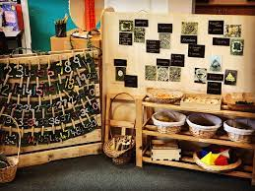  Continuous Provision  A variety of resources are provided both in the classroom and outside for children to creatively interact with. Continuous provision encourages the children to enhance previously taught concepts and make connections independently.

