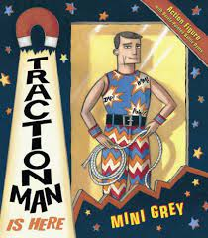  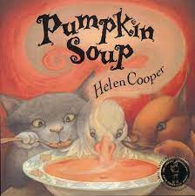  English  Through our core texts shown we will explore writing recounts, narratives and letters. In addition, we will continue to focus on our spelling rules through Jolly Phonics Grammar. | History: Great Fire of London  We will learn that society and the way people lived was different in the past. Also, that events happened outside of living memory and that there are influential figures in history who have had an impact on life today. | Physical Education  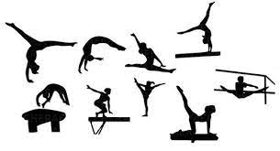  On a Monday we will practise our invasion skills with an external coach and on a Wednesday we will move onto gymnastics in the hall looking at rhythm and balance. | Design Technology - building houses  We will think of ideas and plan what to do next whilst choosing the the best tools and materials.  In addition, we will give a reason why these are best tools or materials and describe our designs using pictures, diagrams, model mock-ups, words and ICT.
RSE  We will discuss our hopes and fears for the year, our rights and responsibilities and our rewards and consequences. We will discuss valuing contributions, choices and recognising feelings. |  |  | Music  We will play instruments with control maintaining steady beat, getting faster or slower, getting louder or quieter. In addition, we will perform a rhythm accompaniment to a song and perform a sequence of sounds using a graphic score.
Maths We will follow the White Rose Maths scheme of work and recap place value before moving onto addition and subtraction word problems. In addition, we are focusing on our 2, 5 and 10x tables.  Science – Animals including Humans  We will learn that different animals move in in different ways in order to survive. We will explore how exercise keeps animal’s bodies in good condition and increases survival chances. | 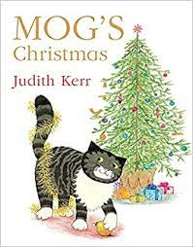  Year 2  Autumn 2 | Computing  We will explore the majority of technology devices have access to the internet/that information is personal and should not be shared online.  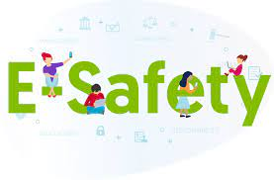  In addition, we will discuss how to act if inappropriate content is found online. | Geography – Morpeth/Newcastle  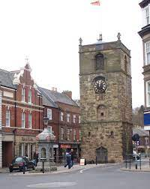  We will gain knowledge of what is a town and a city. We will compare and contrast Hadston, Red Row, Morpeth and Newcastle and identify where we live on a map. Furthermore, we will create maps of our local area with a key and use a map and compass to navigate around new places.
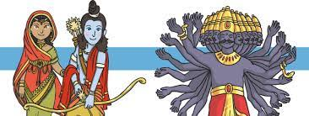  Religious Education We will explore a variety of festivals and celebrations, in particular Diwali (Hinduism). We will learn all about the story of Rama and Sita and explore questions about belonging, meaning and truth. |  |  | Home/School  We will continue to read through our Jolly Phonic home readers and enjoy our weekly reading for pleasure book. In addition, we will practise our tricky word flashcards and work on our times table rockstars.

