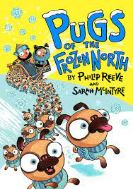  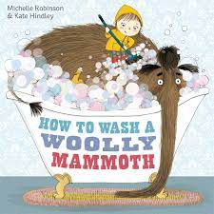  English - Through our core texts we will write in a variety of different genres including poetry, letters, narrative and recounts. In addition, we will be progressing on with our stand alone Jolly Grammar sessions twice weekly and spelling tests containing high frequency words and topic words. | History – Mining  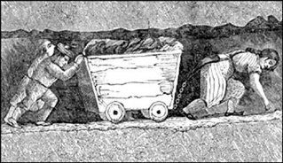  We will gain an understanding of mining events that happened in recent and local history and how they have shaped our lives today. In addition, we will explore the similarities and differences of society and research the way certain people lived in the past. | Physical Education –  Swimming  We will attend a weekly swimming lesson once a week at our nearby pool.  Gymnastics  Using our gymnastics equipment in the hall, we will use the apparatus to develop our balance and core strength using a range of movements in paired and group work.  Computing  We will revisit e-safety and explore using technology purposefully.  Home/School  We will continue to enjoy our weekly home reader/reading for pleasure book. We will continue to practise our tricky word flashcards and work on our times table rockstars. | Art - Andy Warhol  Through our artist we will ensure our design meets a range of requirements.  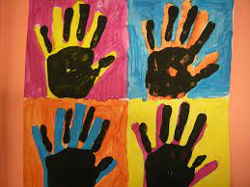  In our sketch books we will describe our designs using an accurately labelled sketch and words and suggest improvements to my work by keeping notes in our sketch books. | Spanish –  We will learn simple meet and greet phrases through role play focusing on our pronunciation. In addition, we will learn body parts through simple songs and role play.
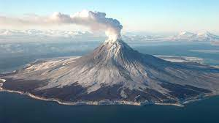
Geography – Volcanoes
We will explore what happens when a volcano erupts and the features of volcanoes. In addition, we will understand what tectonic plates are and what the ‘ring of fire’ is and explore life in volcanic areas.
Maths - Through our white rose maths scheme we will explore place value, reasoning within 100, multiplication and division word problems, 3D numbers and time. | Year 3  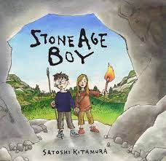  Autumn 2 |  | Music – Perform/Active learning  We will sing songs in a variety of styles with confidence and we will chant or sing a round in two parts and sing songs with a recognised structure (verse and chorus/ call and response). We have weekly drumming lessons where we explore the different sounds (timbres) that one instrument can make and how musical elements can be combined to compose descriptive music. | Religious Education  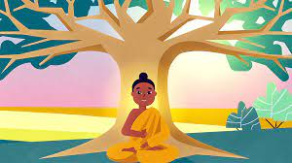  We will investigate different symbols and actions which express a community’s way of life, appreciating some similarities between communities.
Science – Rocks & Fossils/Lights
We will compare and group together different kinds of rocks, describe how fossils are formed when things that have lived are trapped within rock and recognise that soils are made from rocks and organic matter. In addition, we will notice that light is reflected from surfaces and recognise that shadows are formed when the light from a light source is blocked by a solid object.

RSE - Keeping/staying safe/healthy/ Feelings and emotions
We will explore family roles and responsibilities, friendship and negotiation. In addition, we will become aware of how our choices affect others, how other children have different lives and express. appreciation for family and friends.

