English - Through our core texts we will write in a variety of different genres including poetry, letters, narrative and recounts. In addition, we will be progressing on with our stand alone Jolly Grammar sessions twice weekly and spelling tests containing high frequency words and topic words. | History – Ancient Egyptians  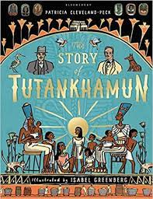  We will begin to picture what life would have been like for the early settlers and suggest why certain events happened. We will suggest why certain people acted as they did in history and explain how events from the past have helped shape our lives. In addition, we will recognise how archaeologists help us understand more about what happened in the past. | Physical Education –  Swimming  We will attend a weekly swimming lesson once a week at our nearby pool. | Art - Romero Britto  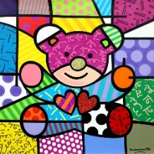  Through painting we will use shading to create mood and feeling and create all the colours required for our painting. We will use colour to create mood in our painting.  Music – Perform/Active learning  We will begin to show an increasing awareness of the tone of our voices and will sing songs showing musical expression (phrasing, changes of tempi, dynamics; reflecting the mood and character of the song and its context).  In addition, children will attend weekly drumming lessons where they will combine instrumental playing with narrative and movement. | Spanish –  Children will build on their Spanish vocabulary and learn words/phases centred around ‘My Town’.  Religious Education – Judaism  We will understand Judaism beliefs which highlight the beginning of Judaism 4000 years ago, the ten commandments, artefacts to do with prayer and home, features of a synagogue and role of a Rabbi and other aspects of Judaism such as the celebration of Passover.
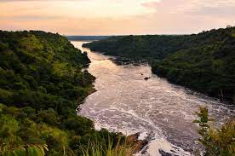  Geography – Rivers and the water cycle  We will look in depth at the River Nile, describing the location and features. We will explore the journey of the River Nile from source to mouth and find out the positive and negative effects of the Aswan High Dam on the River Nile. In addition, we will identify uses for the River Nile and how these have changed over time before describing in detail a journey up the River Nile in Egypt. |  | Gymnastics  We will work on our core strength and balance through routines/group work.  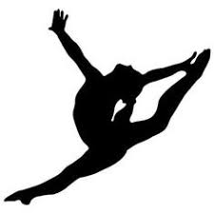
Maths -Through our white rose maths scheme we will explore, measurement and time before moving onto Geometry looking at shape and symmetry then area and perimeter. | 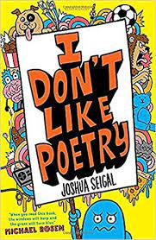  Year 4  Autumn 2 | Hockey  We will play against each other by trying to manoeuvre a ball using hockey sticks.
RSE - Being responsible/Keeping safe/The working world
In particular, we will focus on being unique, our confidence in change, accepting change and environmental change gaining insight into the working world.
Science – States of Matter  Children will compare and group materials together, according to whether they are solids, liquids or gases and observe that some materials change state when heated or cooled, and measure and research the temperature at which this happens in degrees Celsius. They will identify the part played by evaporation and condensation in the water cycle and associate the rate of evaporation with temperature. | Home/School  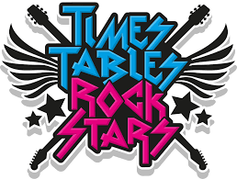  We will continue to enjoy our weekly home reader/reading for pleasure book, practise our tricky word flashcards and work on our times table rockstars. | Computing  We will revisit internet safety.  Using technology purposefully

