English  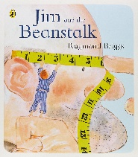  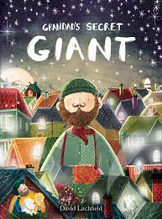  We will continue to revise our sounds looking at segmenting and blending in Jolly Phonics. For our grammar we will follow Jolly Grammar. Through our texts below we will explore writing poetry, recounts and letters.  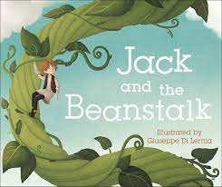 | 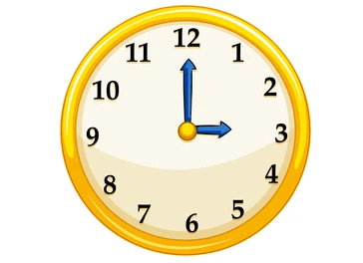  Maths  We will firstly continue with number – exploring calculation strategies within 20 before moving onto a unit of measurement and in particular looking at time. | Physical Education  We will focus on a unit of dance where children will explore basic body actions, e.g. jumping and turning, and use different parts of their body to make movements. They will create and repeat short dances inspired by themes such as penguins and folk dance. | Design Technology  (Cooking and nutrition)  Children will learn how to cut food safely and explain what it means to be hygienic. They will describe the textures of food and think of interesting ways to decorate. Finally, they will explain healthy foods are and say where food comes from.
Art – Henri Matisse  Through our artist, children will learn to create moods in their drawings and draw lines of different shapes and thickness, using 2 different grades of pencil. They will create tones using light and dark.  Additionally, through painting children will explore mixing paint to create all the secondary colours, mixing and matching colours and making tints by adding white and black. | Year 1  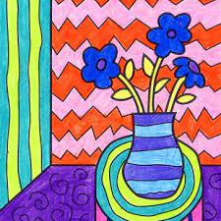  Spring 1 | Computing  Children will focus on using technology purposefully to create, organise, store, manipulate and retrieve digital content. They will recognise common uses of information technology beyond school. | Music (exploring/composing)  Exploring: using different sounds made by the voice and hands  Composing: Choose musical sound effects to follow a story line or match a picture and using graphics/symbols to portray the sounds they have made.
Science – Animals inc humans  We will identify and name a variety of common animals including fish, amphibians, reptiles, birds and mammals. •  Additionally, we will name a variety of common animals that are carnivores, herbivores and omnivores and gain an understand that there are many different animals with different characteristics. | Geography – Amble  We will explore the town we live in and describe where we live. Additionally, we will identify characteristics of the countries of the UK  name the seven continents of the world locating the UK on a world map. | PHSE  We will explore our similarities and celebrate the differences in everyone. Additionally, we will gain a further understanding of bullying and knowing how to deal with it and look at making new friends. | Home/School  We will reinforce the taught sounds in class through our Jolly Phonic home readers and enjoy our weekly reading for pleasure book. In addition, we will practise our tricky word flashcards and work on our times table rockstars.

