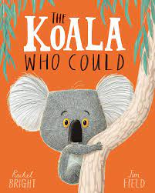  English  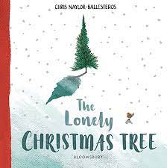  We will continue to explore our alternative sounds in Jolly Phonics and for our grammar we will follow Jolly Grammar. Through our texts below we will explore writing poetry, recounts and letters. | 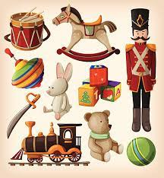  History – Toys  We will learn that some objects belong to the past and put up to three objects in chronological order.  In addition, we will begin to identify the main differences between old and new objects. | Physical Education  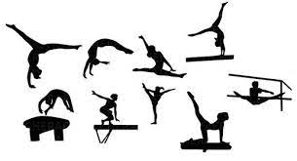  On a Monday we will practise our sending and receiving with an external coach and on a Tuesday we will move onto gymnastics in the hall looking at rhythm and balance. | Design Technology  Linking in with our history topic, we will design a toy. We will think ideas individually and as a class before using pictures and words to plan. Finally, we will design a toy following design criteria and explain what we are making.
Maths  In maths we will follow the White Rose Maths scheme of work and investigate place value to 20 before moving onto addition and subtraction to 20. | Year 1  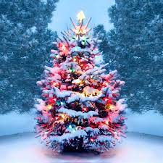  Autumn 2 | Computing  I will learn how to act if I find inappropriate content online and understand that things sometimes happen on computers that are not my fault; E,g, pop- ups).  In addition, I will explore emotions if something comes on the screen that makes me feel bad and learn how to follow I follow the school’s safer internet rules. | Music – Active Performing  We will use our voices to sing songs in different styles conveying different moods (happy, sad, angry etc) and with sense of enjoyment. In addition, we will use our classroom instruments to play instruments by shaking, scraping, rattling, tapping etc.
Religious Education
We will recall and name different beliefs and practices, including festivals, worship, rituals and ways of life, in order to find out about the meanings behind them.
We will learn that Christians believe that the son of God was born on Christmas day named Jesus and that he was a gift to us on earth.
Science - Materials  We will identify and name a variety of everyday materials, including wood, metal, plastic, glass, water and rock.  Describe the simple physical properties of a variety of everyday materials.  Compare and group together a variety of everyday materials on the basis of their simple properties. | Geography - Hadston  We will recognise similarities and differences in our immediate environment. We will discuss where we live and talk about home and family. We will develop maps of the local area and say where the shops are in Hadston. | PHSE  We will explore feeling safe and special as an individual and discuss being part of a class.  In addition, we will think about our rights and responsibilities, rewards and consequences. | Home/School  We will reinforce the taught sounds in class through our Jolly Phonic home readers and enjoy our weekly reading for pleasure book. In addition, we will practise our tricky word flashcards and work on our times table rockstars.

