English  We will explore a range of genres through our Roman Britain topic such as narrative and poetry using the key texts below.  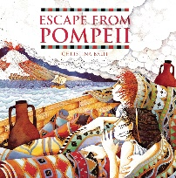  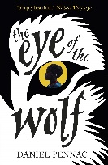  In addition, we will continue to progress through out Jolly Grammar with two stand-alone spelling and grammar lessons each week. | Maths  We will continue with our number work and explore fractions before moving onto statistics looking at graphs and data. Finally, we will investigate decimals through our number work. | Spanish  We will take part in role play speaking Spanish learning to greet and respond in Spanish. Additionally, we will learn to ask/answer questions in a shop and ask/answer how much something costs. | Physical Education  Swimming - We will attend a weekly swimming lesson at our nearby pool.  Dance – We will show an awareness of control when performing and recognise the timing of the sounds in a piece of music. We will work in groups to move our body in time with the music and plan a dance that fits the music. | Design Technology  Through our Roman topic we will design Roman pottery and shields.  We will learn to print using four colours and create accurate print designs on a range of different materials.  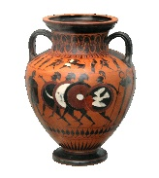  Furthermore, we will learn to work with real-life size models and experiment with design to make 3D form.
History –  We will explore when the Romans conquered Britain and recall some facts about the Romanisation of Britain.  Moving forward, we will describe some aspects of Roman Britain in significant detail through asking and answering questions to demonstrate our understanding.  Finally, we will demonstrate a deeper understanding of the topic and recognise how Britain has been influenced and shaped by the Roman occupation. | Year 4  Spring 1 |  |  | 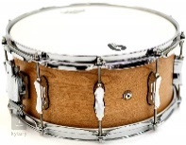  Music  Through our weekly drumming lessons, we will maintain two or more different ostinato patterns in a small instrumental group against a steady beat. We will use tuned percussion instruments with increasing confidence to accompany songs and find known phrases or short melodies using tuned instruments. Additionally, we will learn to read and play from conventional music symbols and combine instrumental playing with narrative and movement.
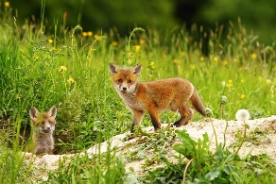  Science – living things and their habitats  We will recognise that living things can be grouped in a variety of ways and explore and use classification keys to help group, identify and name a variety of living things in their local and wider environment.  Additionally, we will recognise that environments can change and that this can sometimes pose danger to living things. |  | Computing –  We will identify how word order affects search results and explain how searches return results. In addition, we will save webpages and share them safely. | RSE  We will explore our hopes and dreams and how to overcome disappointment.  Furthermore, we will explore creating new, realistic dreams and achieving goals. | 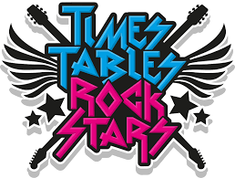  Home/School  We will continue to enjoy our home reader/reading for pleasure book. We will continue to practise our tricky word flashcards and work on our times table rockstars.

